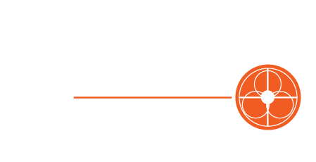

Sermon Series:
To seek and to save:

Talking to Yourself Yourselves
Colossians 3:16
July 15th, 2018

Three questions we can ask:
1. Is the Bible living in my life?

2. Is worship changing me?

3. Am I expressing my heart through song?

Worship and edification are interdependent.

